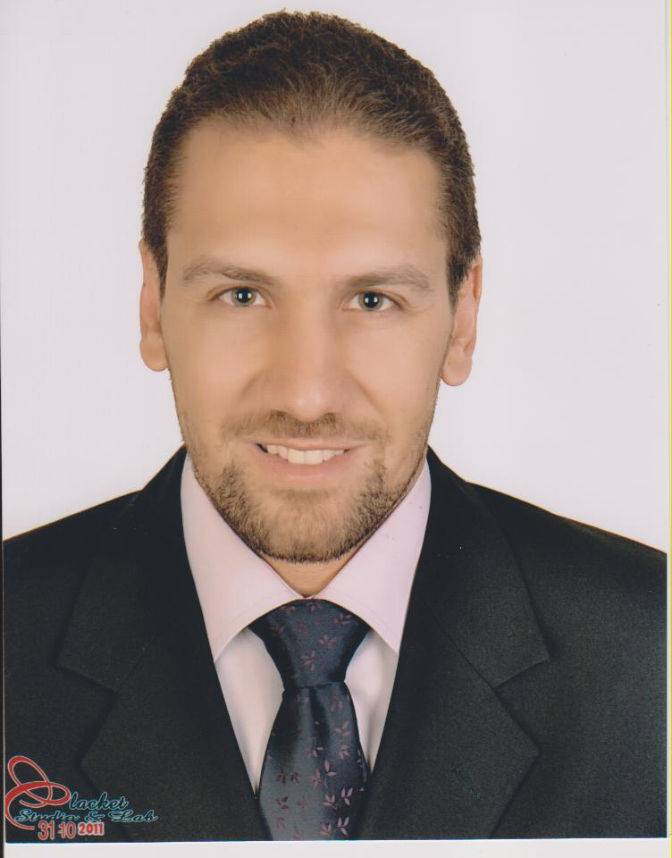 | Tarek Wael Youssef  + 966 56 1414930 / +973 33524615   Ty@tarekyousef.com
Professional Profile
Managing Partner– ControlTap/Quality Leaders/Amfco/Gulf Icon KSA / Bahrain

- An inquisitive, key strategic change driver with almost 30 years of result driven and quantitative experience in planning operations backed by proven abilities in enhancing corporate image, ensuring image uplift, acceptability, and positioning, resulting in increased business as well as uninterrupted business growth.
- Successful track record of making visible contribution to raise productivity with deft application of management operations, business management, finance, and administration.
- Highly valued for expertise in interpreting corporate vision and strategy, translating objectives into actionable plans to achieve Operations, P&L/ROI objectives and providing decisive leadership to multi-functional teams.
- Demonstrative experience in handling business change impact, business readiness, broadening market penetration, defining SLA’s/KPI’s to attain various major breakthroughs in highly competitive market.
- Business management professional with continued career progression of bridging process and managerial acumen in business delivery & roll-out, planning & vision for future projects and process management
- Multi-talented Senior Executive who brings best business practices, clean operational strategy, and revenue-generating ideas to execute projects and manage operations.
- Possesses the powerful combination of sales acumen and vision-branding to position new enterprises ahead of well-established competitors by setting up management distribution processes, developing and managing key accounts.
- Gained extensive experience in developing a huge network base across Engineering, Process, contracting, Metals and Steel Industries
- Proven experience in understanding the needs and implementing measures for setting up & executing various Turnkey field projects along with strategizing measures streamline various functions, including HR management, recruitment, vendor management, production, finance & project management, quality assurance and materials management.
- Successful in building the EPI practice in East practically from scratch based out of KSA/EGYPT/BAHRAIN and instrumental in executing multiple mandates at senior levels in KSA/EGYPT/ BAHRAIN and has tremendous success rates inworking with Expats.
- Industrious individual who thrives on a challenge, working effectively with all levels of management, analytical abilities & creativity to contribute to the team deliverables.
Professional Skill Set
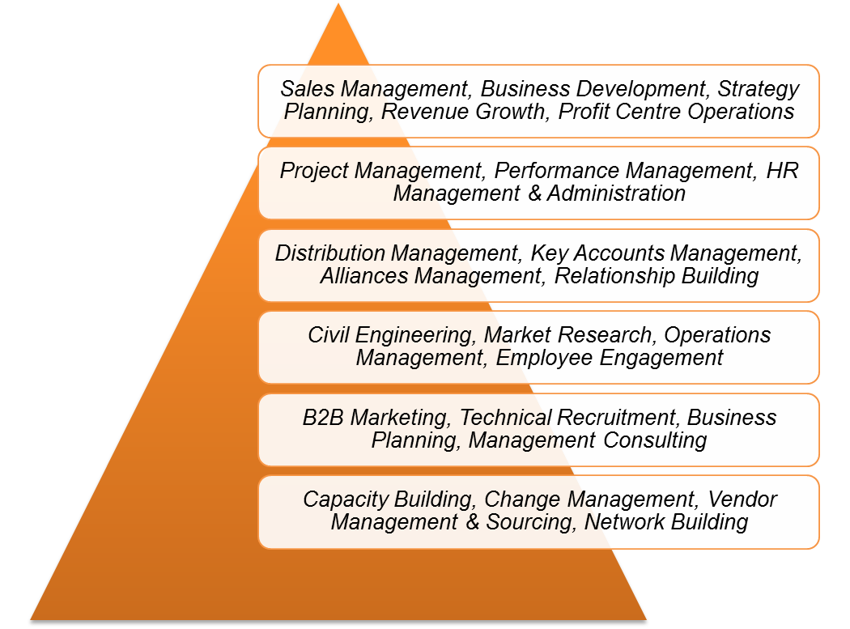

CAREER REVIEW

- Instrumental in building National Practice of Turnkey Contracting, Metals & Steel with entire end to end accountability of the P&L in assigned vertical.
- Stellar in establishing and initiating the business operations and the EPI practice in East for the company right from scratch by developing key accounts and strategizing distribution roadmap.
- Hold credentials in creating and managing a Lean team to deliver on mandates, developing business and professional relationship with clients and candidates.
- Have a successful record in generating and increasing revenue, Company growth, profit.
- Capable of making a reduction and optimization in the cost of operation to increase company profit.
- Have the ability to increase the market penetration and market share.
- Have the ability to open new markets in Africa.

CAREER REVIEW

May 2018 – Till Present –: Managing Partner– ControlTap/Quality Leaders/Amfco/Gulf Icon - KSA / Bahrain

Key Deliverables in addition to the ones of Managing Partner mentioned below:

- Spend a good deal of time interacting with clients and other building professionals.
- collaborating with architects, engineers, inspectors, consultant, clients, sub-contractors, and other building specialists.
- Increases management's effectiveness by recruiting, selecting, orienting, training, coaching, counseling, and disciplining managers; communicating values, strategies, and objectives; assigning accountabilities; planning, monitoring, and appraising job results; developing incentives; developing a climate for offering information and opinions; providing educational opportunities.
- Develops strategic plan by studying technological and financial opportunities; presenting assumptions; recommending objectives.
- Accomplishes subsidiary objectives by establishing plans, budgets, and results measurements; allocating resources; reviewing progress; making mid-course corrections.
- Coordinates efforts by establishing procurement, finance, production, marketing, field, and technical services policies, and practices; coordinating actions with corporate staff.
- Build company image by collaborating with customers, government, community organizations, and employees, enforcing ethical business practices.
- Maintains quality service by establishing and enforcing organization standards.
- Maintains professional and technical knowledge by attending educational workshops; reviewing professional publications; establishing personal networks; benchmarking state-of-the-art practices; participating in professional societies.
- Contributes to team effort by accomplishing related results as needed.

PAST EXPERIENCE

August 2016 – May 2018: Alex Group – Vice President - Egypt

Key Deliverables in addition to the ones of Vice President mentioned below:

- Develop plans and strategies for developing business and achieving the company’s sales goals.
- Create a culture of success and ongoing business and goal achievement – possibly more important than the first item on this list.
- Communicate company strategy to board of directors.
- Attend board meetings.
- Oversee revenue generation and identify ways to generate and maximize revenue.
- Work with audit and finance committee to prepare budgets.
- Analyze financial reports.
- Ensure company policy and procedures are followed by each department.
- Report and share information with board to ensure that they are kept fully informed on the condition of the organization and important factors influencing it.
- Ensure highly productive relationships and partnerships for the benefit of the group.
- Set goals, monitor work, and evaluate results to ensure that departmental and organizational objectives and operating requirements are met and are in line with the needs and mission of the organization.
- Work alongside community leaders, executive directors, major donors/funders, governmental officials, and senior staff/board members.
- Participate in nurture broad networks of alliances with others to exchange knowledge and information about learning and change in support of change initiatives.

July 2015 - August 2016 : Arcelor Mittal Co. - Country Manager-KSA

- Entrusting with the onus of establishing Businesses operations by thinking up and putting into practice innovative business strategies to improve the product awareness and ensure enhanced brand visibility.
- Defining and effectively presenting consistent company position and message through all avenues of contacts while developing reputation in line with company business-growth objectives
- Exceeding revenue objectives while continuously created opportunities for revenue generation in a professional manner and achieving assigned targets by maintaining quality business relationship.
- Establishing practice innovative business strategies to improve the awareness & ensuring enhanced visibility and gearing activities to plan, organize, & manage internal procedures and resources to ensure maximum productivity.
- Executing the planning of Annual Revenue Budget, compared with actual and making variance analysis, recommending course corrections if required.
- Responsible for diversification of business, addition of new business verticals, identification of projects by creating and executing various business strategies, goals, and objectives into practically achievable plant performance indicators.
- Creating and maintaining a good environment and team spirit within the business by effective communication motivation, mentoring and delegation skills
- Effectively discussing the strategies and other required information while building collaborative environment with the top management, advisors and reporting about the ongoing activities
- Setting and fine-tuning an excellent operating base which is ratified by a very high customer retention ratio, focused on productivity and operational efficiency translating into cost savings and bottom-line improvement.
- Planning and conceptualizing various strategies to achieve business goals aimed towards the growth in business volumes as well as profitability while analyzing cost effectiveness and competitor’s strategies and proceeding.
- Identifying and exploiting opportunities in existing business through introductions from existing business unit / division management and developing & maintaining culture, values, and reputation in its markets, customers, and suppliers
- Building a cohesive team spirit throughout the company by designing program that recognized competing management objectives, created common goals, and provided measurable incentives.
- Builder and leader of HR environments that capitalizes on planning, developing new processes, and using technology to achieve organizational objectives.
- Executing strategies that improve employee satisfaction, retention, and engagement and responsible for identification of position gaps while ensuring right staffing within prescribed timelines.
- Being in charge of establishing the Area offices, recruiting and managing staff, including performance monitoring, and mentoring and training, setting up the organization chart and reporting system
- Setting up the stock yards and Steel Stock management for purchasing and selling
- Daily contact with clients, therefore the ability to communicate effectively with clients’ top management and establishing excellent networking with them.

December 2013 – July 2015 : Senior Area Manager – KSA & Bahrain - Zamil Steel Co.

- In charge of KSA & Bahrain markets
- Making strategic analysis for both markets
- Implementing strategies to achieve targets & goals set by management.
- Forecasting upcoming projects in the market and making sure to secure it.
- Building on & expanding the client base of the company to increase company’s market share.
- Preparing sales & marketing plan and discussing it with top management
- Preparing weekly and monthly reports in addition to preparing the area presentation(s) for the semi-annual meetings with the top management
- Setting targets for all sales staff
- Follow up with all sales staff the forecasts and job entries.
- Following up with clients to ensure their satisfaction at all stages, and to be always updated about the project status.
- Approving selling prices and order entries
- Follow up with all departments for orders before and after entries.
- Managing the erection work at site until complete handover of projects
- Getting total turnkey projects including erection, civil, & electro-mechanic

September 2011 – December 2013 : Area Manager – Zamil Steel Co. – Kingdom of Saudi Arabia – Dammam

- Reporting directly to the VP of Zamil Steel
- Generate business opportunities for the company.
- Establish long-term business relationships with customers, clients and government offices and supervise the activities of the office staff to ensure complete adherence to company’s policies.
- Ensure development of Zamil brand and increase market share of products through right market approach.
- Define overall sales & business development strategy for products, customers & markets.
- Define annual budget, quarterly targets and ensure meeting the targets.
- Identify opportunities for growth, and support business development.
- Lead and manage key accounts to ensure increased revenue & customer satisfaction.
- Expand sales network through builders and agents in remote areas.
- Review sales forecasts, identify improvements & monitor implementation of these forecast.

June 2010 – September 2011 : Area Manager – Energya Steel Solutions – Al Sewedy Co. – Kingdom of Saudi Arabia

June 2005 – June 2010 : AREA Sales MANAGER, Kirby Building Systems- Kuwait, Dammam, Kingdom of Saudi Arabia

July 2000 – June 2005 : Senior Sales and project Engineer, Zamil Steel Buildings Company, Cairo, Egypt

July 1996 – July 2000 : Site Supervisor Engineer, Arab Consultant engineers - Egypt

- Supervision for the Construction of the Extension of 6th October Bridge – Cairo & Suez Canal Cable Stayed Bridge in Qantara City in coordination with PCI & Chodai Companies (Japanese Consultants)
- Cable stayed bridge (pylon) using sleep forms- cantilever carriage.
- Continuous 40m spans pre-stressed using couplers, movable shuttering (Flying Shuttering)
- A simply 40m spans pre-stressed using U- form, formworks.
- Floating Bay- Reinforced Concrete 50m spans
- Revising and approving shop drawings submitted by the main contractors.
- Site supervision for bored piles with diameter up to 1.80m and depth up to 40m
- Site supervision for pile caps preparation and casting which used up to 4000m3 of concrete, which was casted over 74 no. Group of piles by using self-formed shuttering.
- Site supervision for casting concrete for Twin Pylons with different solid and hollow cross sections by using slip form shuttering and anchoring for the Re-bars.
- Site supervision for continuous and simple 40m super structure spans by using the pre-stressing system using couplers, movable shuttering (Flying Shuttering)
- Site supervision for erecting the cables connected between the pylon and the steel superstructure for the lifting and stability of the steel superstructure.

TRAININGS

- Construction of Civil Aviation Authority by Hassan Allam Dorra c/o with Egypt Air- 1993
- Construction of Water Supply & Sewer System Upgrading in Monib- Giza by DAI Nippon a Japanese Construction Company- 1994
- Design of Concrete & Steel Buildings in Engineering Design co.-Cairo-1995
- Construction of El- Ahly Club- Nasr City by Arab Contractors- Cairo- 1995

EDUCATION CREDENTIALS
n
ILM – INSTITUTE OF LEADERSHIP & MANAGEMENT [LMD-UK] - 2014

MBA – AMERICAN UNIVERSITY OF LONDON - 2010

SALES & MANAGEMENT DIPLOMA FROM AMERICAN UNIVERSITY IN CAIRO - 2005

SOIL AND FOUNDATION DIPLOMA FROM AIN SHAMS UNIVERSITY – CAIRO - 1999

BACHELOR OF ENGINEERING-CIVIL SECTION STRUCTURE DEPARTMENT-1996 AIN SHAMS UNIVERSITY – CAIRO – EGYPT

HIGH SCHOOL : G.C.E from Abu Dhabi- U.A.E- 1990

PERSONAL DETAILS

Nationality: Egyptian

Date of Birth: 12th November 1974

Linguistic Abilities: Arabic [Mother Tongue], English [Fluent], French [Fair]
Address: RAKAH-KHOBAR-K.S.A. / Egypt - Cairo
Marital Status: Married with Four kids

OVER SEAS TRAVELS

Luxembourg, Netherland, Poland, Korea, England, France, Spain, Italy, Greece, Cyprus, Turkey, Athens, Thailand, Algeria, Saudi Arabia, Bahrain, Kuwait, Emirates, Syria, Kenya, Rwanda and Lebanon

HOBBIES

Sports as General, Music, Travelling, Motorcycle Riding

